Day 6: 22 September 2024

Thymeleaf support form binding concept. Using form binding concept we can use form reference inside Thymeleaf form and we can access that java bean class object as well as their property.

Like a reactive form in angular

Creating new spring boot project

With starter as

Web starter -🡪 Web Application features

Thymeleaf starter 🡪 view

JPA starter -🡪 to get ORM features

My sql connector 🡪 My Sql Database.

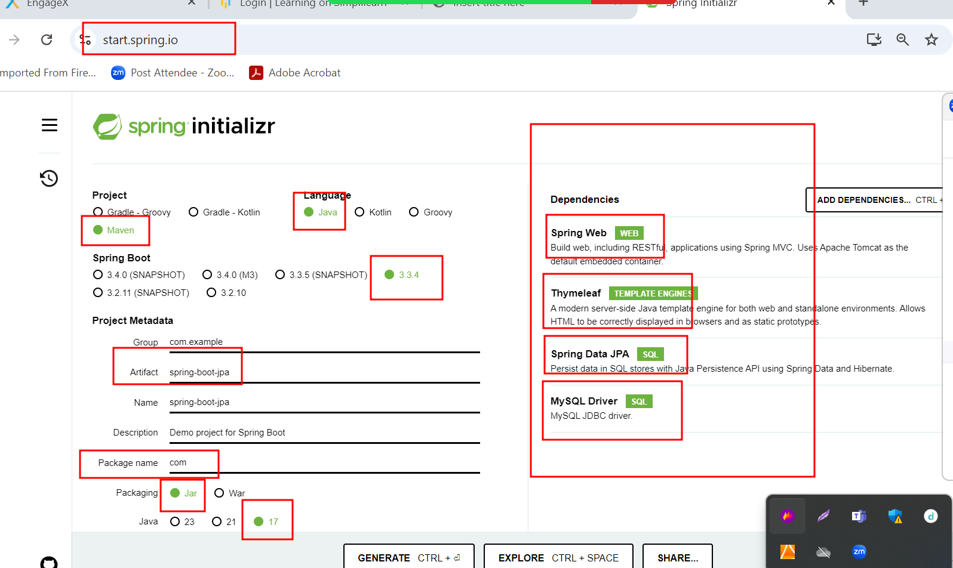

Through JDBC if we do any DML operation

By default auto committed.

But if we want to transaction using jdbc

con.setAutoCommit(false);

then after one or more than DML operation

we need to write

con.commit() or con.rollback();

ORM like JPA or Hibernate by default not auto commit. So we need to use

Transaction in JPA or hibernate.

In JDBC we use SQL

In JPQ we use JPQL (Java persistence Query Language)

SQL is database dependent. JPQL is database independent.

Using SQL we get data from table in string format or sql format.

Using JPQL we get data using entity class in object format.

SQL

Select \* from product : \* means all columns and product is table name. table name is not case sensitive.

Select \* from product where pid=100; pid is column name

Select \* from product where price > 56000; price is column name

JPQL

Select p from Product p : Product is entity class name case sensitive. p is object which contains all variable of entity class.

Select p from Product p where p.pid = 100;

P is object and pid is variable name of entity class